Planning and Environment Act 1987

Surf Coast Planning Scheme

Amendment C148surf

Explanatory Report

Overview
Amendment C148surf implements the recommendations of the Surf Coast Shire Heritage Study Stage 3 (Authentic Heritage Services Pty Ltd, Wendy Jacobs and Landmark Heritage Pty Ltd, May 2026) which assessed the heritage significance of properties located within Birregurra, Inverleigh, Moriac, Mount Moriac, Paraparap and Winchelsea.
It does this by applying the Heritage Overlay to 19 places identified as being of local heritage significance and updates the Schedule to Clause 43.01 (Heritage Overlay) accordingly.
The amendment also incorporates a Statement of Significance for each heritage place and the Surf Coast Shire Heritage Study Stage 3 Permit Exemptions Incorporated Plan, (Surf Coast Shire, October 2026) into the Schedule to Clause 72.04 (Documents Incorporated into this Planning Scheme).

Where you may inspect this amendment
The amendment can be inspected free of charge at:
- Surf Coast Shire website at www.surfcoast.vic.gov.au
- During office hours at the following place:
  - Surf Coast Shire offices, 1 Merrijig Drive, Torquay
- Department of Transport and Planning website at http://www.planning.vic.gov.au/public-inspection or by contacting the office on 1800 789 386 to arrange a time to view the amendment documentation.

Submissions
Any person may make a submission to the planning authority about the amendment. Submissions about the amendment must be received by 22 November 2026.
A submission must be sent to:
Strategic Planning, Surf Coast Shire
By post: PO Box 350 Torquay, VIC 3228
In person: 1 Merrijig Drive, Torquay
By email: info@surfcoast.vic.gov.au

Panel hearing dates
In accordance with clause 4(2) of Ministerial Direction No.15 the following panel hearing dates have been set for this amendment:
- Directions hearing: 22 February 2027
- Panel hearing: 22 March 2027

Details of the amendment

Who is the planning authority?
This amendment has been prepared by the Surf Coast Shire Council, which is the planning authority for this amendment.

Land affected by the amendment
The amendment applies to 19 properties listed below, located within Birregurra, Inverleigh, Moriac, Mount Moriac, Paraparap and Winchelsea.
A mapping reference table is also included at Attachment 1 to this Explanatory Report
Birregurra
- 270 Kildean Road, Birregurra
Inverleigh
- 940 Barwon Park Road, Inverleigh
Moriac
- 545 Cape Otway Road, Moriac
- 550 Cape Otway Road, Moriac
- 561‐563 Cape Otway Road, Moriac
- 565-567 Cape Otway Road, Moriac
- 795 Hendy Main Road, Moriac
Mount Moriac
- 1191 Princes Highway, Mount Moriac
- 805 Reservoir Road, Mount Moriac
- 395 Devon Road, Mount Moriac
Paraparap
- 90 Grassdale Road, Paraparap
Winchelsea
- 30 Batson Street, Winchelsea
- 40 Buhrmanns Road, Winchelsea
- 400 Cressy Road, Winchelsea
- 685 Cressy Road, Winchelsea
- 40 Dicksons Road, Winchelsea
- 190 Kildean Road, Winchelsea
- 70 Lauders Lane, Winchelsea
- 65 Mathisons Road, Winchelsea

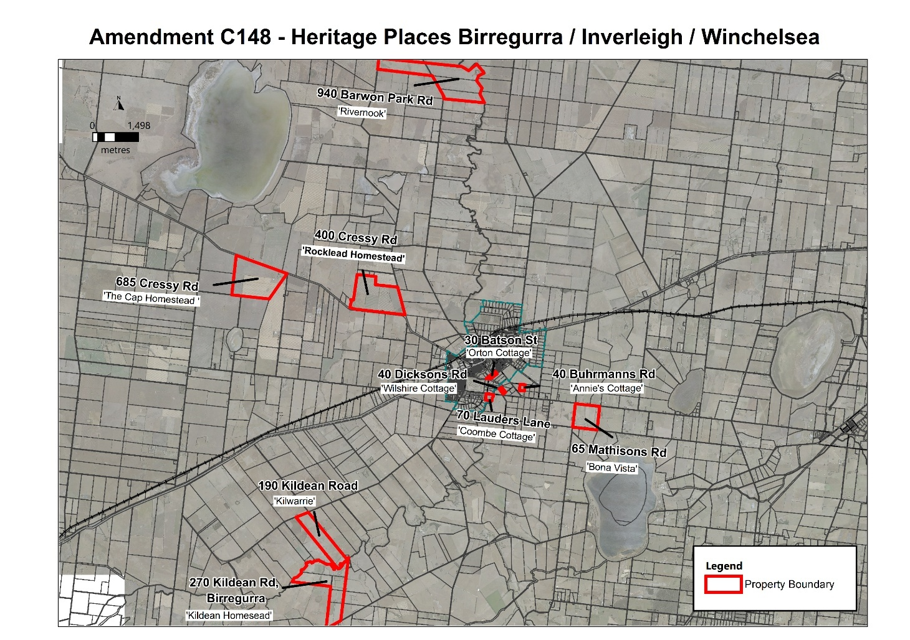
Figure 1: Birregurra / Inverleigh / Winchelsea Heritage Places
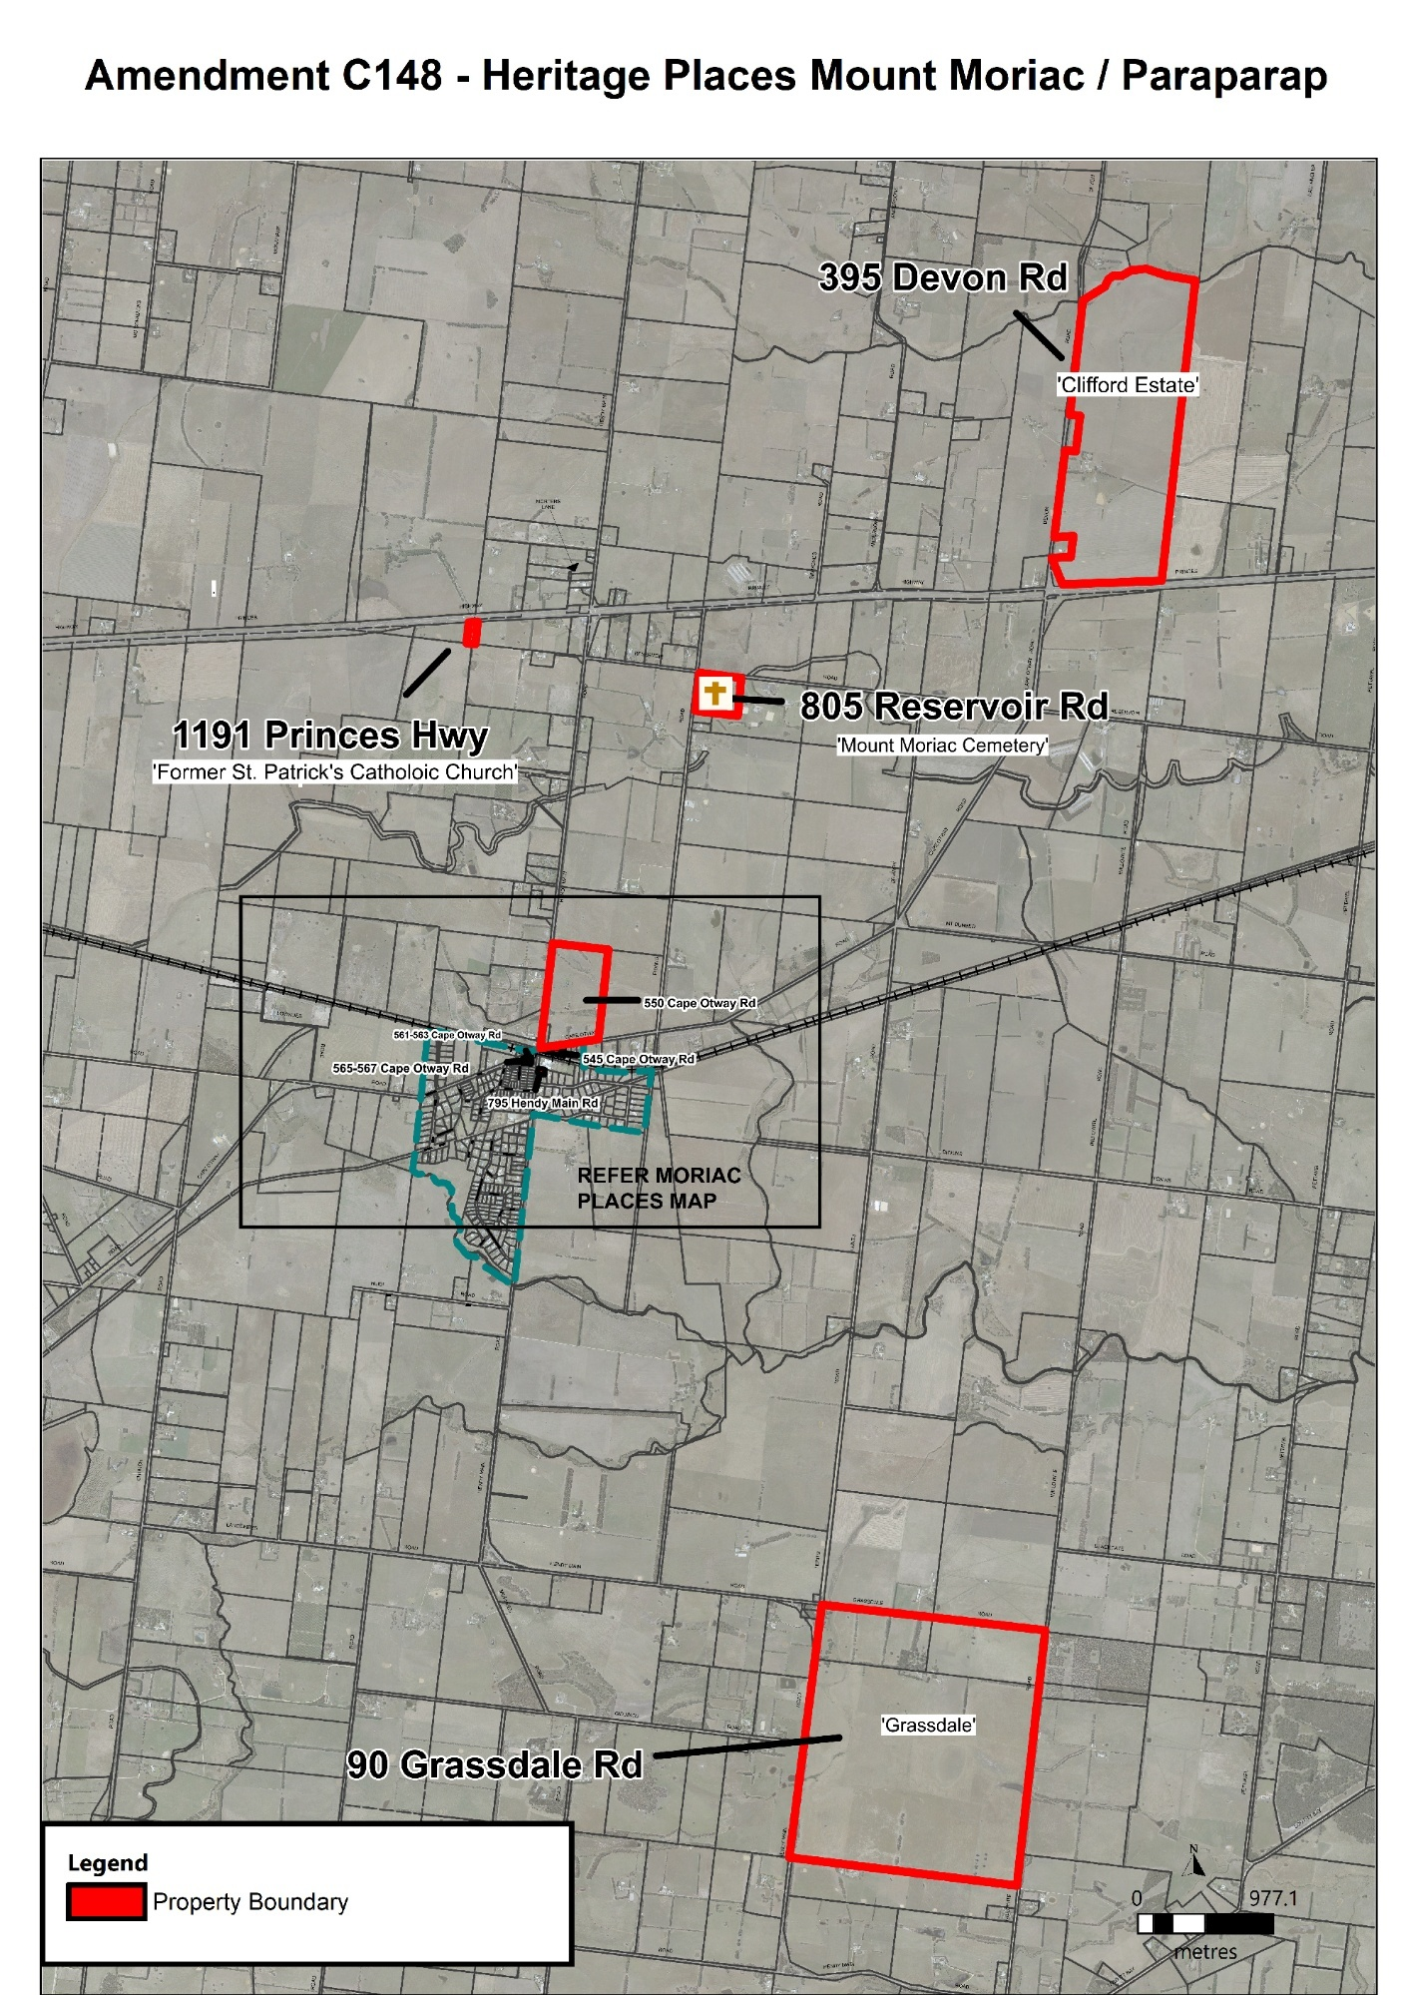
Figure 2: Mount Moriac / Paraparap Heritage Places
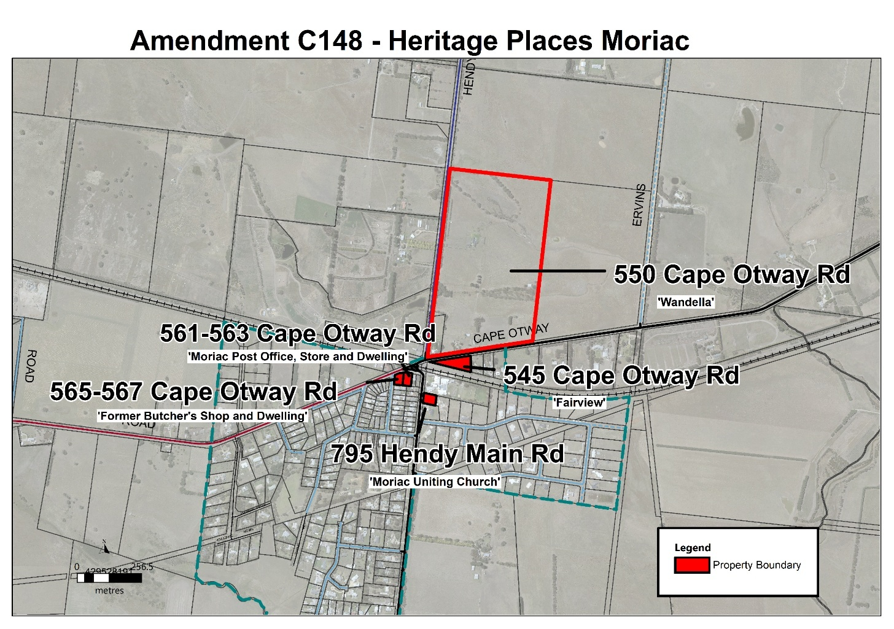
Figure 3: Moriac Heritage Places

What the amendment does

Amendment C148surf implements the recommendations of the Surf Coast Shire Heritage Study Stage 3 (Authentic Heritage Services Pty Ltd, Wendy Jacobs and Landmark Heritage Pty Ltd, May 2026)

It does this by applying the Heritage Overlay to 19 places identified as being of local heritage significance and updates the Schedule to Clause 43.01 (Heritage Overlay) accordingly. The amendment also incorporates a Statement of Significance for each heritage place and the Surf Coast Shire Heritage Study Stage 3 Permit Exemptions Incorporated Plan, (Surf Coast Shire, October 2026) into the Schedule to Clause 72.04 (Documents Incorporated into this Planning Scheme).
Specifically, the amendment:
Overlay maps
- Inserts Planning Scheme Map No. 3HO to apply the Heritage Overlay to HO167, Former Station Store – Rivernook, 940 Barwon Park Road, Inverleigh.
- Inserts Planning Scheme Map No. 11HO to apply the Heritage Overlay to:
- HO168, Fairview, 545 Cape Otway Road, Moriac.
- HO169, Wandella, 550 Cape Otway Road, Moriac.
- HO170, Moriac Post Office, Store and Dwelling, 561‐563 Cape Otway Road Moriac.
- HO171, Former Butcher’s Shop and Dwelling, 565-567 Cape Otway Road, Moriac.
- HO172, Moriac Uniting Church, 795 Hendy Main Road, Moriac.

- Amends Planning Scheme Map No. 7HO to apply the Heritage Overlay to:
- HO180, The Cap Homestead, 685 Cressy Road, Winchelsea.
- HO179, Rocklea Homestead, 400 Cressy Road, Winchelsea.

- Amends Planning Scheme Map No. 8HO to apply the Heritage Overlay to:
- HO177, Orton Cottage, 30 Batson Street, Winchelsea.
- HO178, Annie’s Cottage, 40 Buhrmanns Road, Winchelsea.
- HO181, Wilshire Cottage, 40 Dicksons Road, Winchelsea.
- HO183, Coombe Cottage, 70 Lauders Lane, Winchelsea.

- Amends Planning Scheme Map No. 9HO to apply the Heritage Overlay to HO184, Bona Vista, 65 Mathisons Road, Winchelsea.
- Amends Planning Scheme Map No 12HO to apply the Heritage Overlay to:
- HO173, Former St. Patrick’s Catholic Church, 1191 Princes Highway, Mount Moriac.
- HO174, Mount Moriac Cemetery, 805 Reservoir Road, Mount Moriac.
- HO175, Clifford Estate, 395 Devon Road, Mount Moriac.

- Amends Planning Scheme Map No 24HO to apply the Heritage Overlay to:
- HO166, Kildean Homestead, 270 Kildean Road, Birregurra.
- HO182, Kilwarrie, 190 Kildean Road, Winchelsea.

- Amends Planning Scheme Map No 27HO to apply the Heritage Overlay to HO176, Grassdale Homestead, 90 Grassdale Road, Paraparap.
Ordinance
- Amends Clause 15.03-1L (Heritage conservation) to reference the Surf Coast Shire Heritage Study Stage 3, Volumes 1-3 (Authentic Heritage Services Pty Ltd, Wendy Jacobs and Landmark Heritage Pty Ltd, May, 2026) as a policy document.
- Amends the Schedule to Clause 43.01 (Heritage Overlay) by inserting 19 new heritage places (HO166 to HO184).
- Amends the Schedule to Clause 72.03 (What does this planning scheme consist of?) to include the new Heritage Overlay maps to be inserted into the planning scheme.
- Amends the Schedule to Clause 72.04 (Documents Incorporated in this Planning Scheme) to insert the following incorporated documents:
  - Kildean Homestead 270 Kildean Road, Birregurra Statement of Significance, October 2026.
  - Former Station Store Rivernook 940 Barwon Park Road, Inverleigh Statement of Significance, October 2026.
  - Fairview 545 Cape Otway Road, Moriac Statement of Significance, October 2026.
  - Wandella 550 Cape Otway Road, Moriac Statement of Significance, October 2026.
  - Moriac Post Office, Store and Dwelling 561‐563 Cape Otway Road, Moriac Statement of Significance, October 2026.
  - Former Butcher’s Shop and Dwelling 565-567 Cape Otway Road, Moriac Statement of Significance, October 2026
  - Moriac Uniting Church 795 Hendy Main Road, Moriac Statement of Significance, October 2026.
  - Former St. Patrick’s Catholic Church 1191 Princes Highway, Mount Moriac Statement of Significance, October 2026.
  - Mount Moriac Cemetery: 805 Reservoir Road, Mount Moriac Statement of Significance, October 2026.
  - Clifford 395 Devon Road, Mount Moriac Statement of Significance, October 2026.
  - Grassdale 90 Grassdale Road, Paraparap Statement of Significance, October 2026
  - Orton Cottage 30 Batson Street, Winchelsea Statement of Significance, October 2026.
  - Annie’s Cottage 40 Buhrmanns Road, Winchelsea Statement of Significance, October 2026.
  - Rocklea Homestead 400 Cressy Road, Winchelsea Statement of Significance, October 2026.
  - The Cap Homestead 685 Cressy Road, Winchelsea Statement of Significance, October 2026.
  - Wilshire Cottage 40 Dicksons Road, Winchelsea Statement of Significance, October 2026.
  - Kilwarrie 190 Kildean Road, Birregurra Statement of Significance, October 2026.
  - Coombe Cottage 70 Lauders Lane, Winchelsea Statement of Significance, October 2026.
  - Bona Vista 65 Mathisons Road, Winchelsea Statement of Significance, October 2026.
  - Surf Coast Shire Heritage Study Stage 3 Permit Exemptions Incorporated Plan, October 2026.
- Amends the Schedule to Clause 72.08 (Background Documents) to insert the Surf Coast Shire Heritage Study Stage 3, Volumes 1-3 (Authentic Heritage Services Pty Ltd, Wendy Jacobs and Landmark Heritage Pty Ltd, May 2026) as a background document.

Strategic assessment of the amendment

Why is the amendment required?
The amendment is required to give statutory protection to 19 individually significant heritage places. The amendment implements the recommendations of the Surf Coast Shire Heritage Study Stage 3 (Authentic Heritage Services Pty Ltd, Wendy Jacobs and Landmark Heritage Pty Ltd, May 2026) by applying the Heritage Overlay to 19 places found to satisfy the threshold of ‘Local Significance’.
The list of places was drawn from the Surf Coast Heritage Study Stage 1 Inventory of Places. The Stage 3 Heritage Study built on the work previously undertaken in Stages 1, 2A, 2B and 2C Heritage Studies. Stage 2A involved the assessment and documentation of places in Lorne and Deans Marsh (completed in 2003); Stage 2B was carried out in 2007‐08 and involved the assessment of 80 places at Anglesea, Lorne, Modewarre, Torquay and Winchelsea; and Stage 2C involved assessment of heritage places already subject to heritage overlays where additional heritage assessment was required.
The significance of the heritage places was initially assessed against the heritage criteria contained in Planning Practice Note 1: Applying the Heritage Overlay (2018) and the Legacy Heritage Study Toolkit: Guidelines and Resources for Rural and Regional Councils. The assessment concluded that the identified places met the threshold for local heritage significance and warranted protection through the Heritage Overlay. Consistent with both the former practice note and the current Victorian Local Heritage Guidelines, Statements of Significance have been prepared for each proposed heritage place and are to be included in the Surf Coast Planning Scheme as incorporated documents.
The amendment is consistent with the requirements of the Victorian Local Heritage Guidelines. The heritage places included in the amendment satisfy the relevant heritage criteria and local significance threshold for inclusion in the Heritage Overlay, with each Statement of Significance providing a clear and evidence-based justification for the application of heritage controls.
The Heritage Overlay is the appropriate planning mechanism to protect the heritage values of the individual properties as it requires a planning permit to be granted for building and works, including demolition, that could affect the significance of such places. The overlay will ensure that identified heritage places are properly recognised and decision-making frameworks are in place to assist owners and council to manage sympathetic change to these places.

How does the amendment implement the objectives of planning in Victoria?
The amendment implements the objectives of planning in Victoria as outlined in section 4(1) of the Planning and Environment Act 1987 as follows:
- Provide for the fair, orderly, economic and sustainable use, and development of land;
A Statement of Significance for each heritage place will be incorporated into the planning scheme. This will ensure landowners and the community are aware of the heritage values that apply to each place so that its significance can be protected.
A planning permit exemptions document will also be incorporated into the planning scheme which will specify what buildings and works exemptions apply to each place. This will provide additional transparency to landowners on what works do not require planning approval.
The amendment does not apply the Heritage Overlay to properties identified in the study as having no heritage significance.
- Conserve and enhance those buildings, areas or other places which are of scientific, aesthetic, architectural or historical interest, or otherwise of special cultural value;
The purpose of the amendment is to apply the Heritage Overlay to properties with heritage significance to ensure they are appropriately identified, and their heritage values are considered and protected from inappropriate development.

How does the amendment address any environmental, social and economic effects?
Environmental effects
The amendment is not expected to have any adverse environmental effects. It will provide a mechanism for protection of the Shire’s heritage places and contribute to a diversity of the built environment.

The conservation of heritage buildings has environmental sustainability benefits such as reduction in energy usage associated with demolition, minimising waste disposal from demolition and new construction to landfill. Retaining and adapting heritage buildings promotes sustainable development by conserving the embodied energy in existing buildings.
Social effects
The amendment is expected to have positive social effects through the recognition and protection of sites of historical significance, for the benefit of current and future generations. The protection of these places will benefit the community by:

- Adding to the understanding of the cultural history within the Shire.
- Recognising the positive contribution that historically significant places make to the Shire.
- Providing a link to the past and creating a sense of place and cultural identity.

Inclusion of a site within the Heritage Overlay does not prohibit changes to that site or building. Rather it ensures that any proposed works are subject to a planning permit application process whereby heritage considerations can be properly addressed before any decision on an application is made. This may limit development that is inconsistent with the heritage values of the site, which will improve the character of the building and the wider area.
Economic effects
The amendment is unlikely to have any significant economic impacts. While the amendment may result in some additional cost to proponents of development when compared to an absence of the Heritage Overlay, such costs are not considered unreasonable to ensure heritage places are properly protected and conserved.

Does the amendment address climate change?

The amendment supports climate change adaptation by facilitating the conservation and adaptive reuse of existing buildings. Retaining and maintaining heritage buildings reduces the need for demolition and new construction, thereby avoiding embodied carbon emissions associated with the manufacture, transport and installation of new building materials.

Does the amendment address relevant bushfire risk?
The amendment does not result in increased development potential, nor change of use of land; it will not increase the bushfire risk to life as a priority, property, community infrastructure or the natural environment.

Does the amendment comply with the requirements of any other Minister’s Direction applicable to the amendment?
The amendment is consistent with Ministerial Direction - The Form and Content of Planning Schemes, as identified in Section 7(5) of the Planning and Environment Act 1987.
The preparation of this explanatory report has been completed in accordance with the content of Ministerial Direction No 11 - Strategic Assessment of Amendments to ensure a comprehensive strategic evaluation of the amendment, and the outcomes it produces, has been undertaken.

How does the amendment support or implement the Planning Policy Framework?
The amendment is consistent with the following clause of the Planning Policy Framework and will assist in achieving its objectives:
Clause 15.03 – Heritage
The amendment is consistent with the objective of this Clause “to ensure the conservation of places of heritage significance”.
This is achieved by the following strategies:
- Provide for the protection of natural heritage sites and man-made resources.
- Provide for the conservation and enhancement of those places that are of aesthetic, archaeological, architectural, cultural, scientific or social significance.
- Encourage appropriate development that respects places with identified heritage values.
- Retain those elements that contribute to the importance of the heritage place.
- Encourage the conservation and restoration of contributory elements of a heritage place.
- Ensure an appropriate setting and context for heritage places is maintained or enhanced.
- Support adaptive reuse of heritage buildings where their use has become redundant.
The amendment ensures the list of places identified in the Surf Coast Shire Heritage Study Stage 3 as locally significant are recognised and protected in the planning scheme and decisions about the future of these places consider any impacts on the significance of each place.

How does the amendment support or implement any relevant strategic plan or policy statement adopted by a Minister, government department or public authority?

The amendment implements Clause 15.03-1S (Heritage Conservation) of the Planning Policy Framework by providing statutory protection for places of local heritage significance identified through the Surf Coast Shire Heritage Study Stage 3. The amendment has been prepared in accordance with the Victorian Local Heritage Guidelines and is supported by Statements of Significance that demonstrate the significance of each place and justify the application of the Heritage Overlay.
By recognising and protecting places of local heritage significance, the amendment supports the Victorian Government's objective of conserving cultural heritage as part of Victoria's built and cultural environment for present and future generations.

Is the amendment consistent with the delivery of the relevant housing target set out in the Planning Policy Framework?
The amendment is consistent with the delivery of Surf Coasts housing target set out in the Planning Policy Framework. The amendment applies heritage controls to a limited number of places located predominantly within the municipality's hinterland townships and rural areas, outside locations identified for future urban growth. As such, the amendment is not expected to have a material impact on the supply, diversity or delivery of housing.
The only heritage place located within a designated future growth area is Orton Cottage, 30 Batson Street, Winchelsea. The significance of this place can be appropriately managed and integrated into the future development of the surrounding land. Accordingly, the amendment is not expected to prejudice the achievement of housing targets or the planned growth of the municipality.

How does the amendment support or implement the Municipal Planning Strategy?
The amendment supports the Municipal Planning Strategy of the Surf Coast Planning Scheme, specifically at:
Clause 02.03-5 Built Environment - Heritage - Council seeks to:
- Conserve Aboriginal and post-European contact cultural heritage places in the Shire and manage change in a manner that enhances their significance.

How does the amendment balance any competing policy objectives or strategies?
The amendment balances competing policy objectives by conserving places of local heritage significance while ensuring the municipality can continue to accommodate future growth and development. The amendment applies predominantly to heritage places located within hinterland townships and rural areas and is not expected to materially affect land identified for future urban growth. The Heritage Overlay does not prevent development but guides change so that heritage values are appropriately managed. In this way, the amendment achieves a balance between the objectives of heritage conservation, sustainable development and future growth.

Does the amendment make proper use of the Victoria Planning Provisions?

The amendment makes proper use of the Victoria Planning Provisions by applying the Heritage Overlay to places of local heritage significance. The HO is the appropriate mechanism for recognising heritage values in the planning scheme as its purpose is to conserve and enhance heritage places of natural or cultural significance and those elements which contribute to the significance of heritage places.

The amendment makes proper use of incorporated documents to define the contributory elements that comprise the heritage significance of the places affected by the amendment.

The amendment is consistent with the requirements of the Victorian Local Heritage Guidelines. All places meet the criteria for inclusion in the heritage overlay as outlined in the Guidelines with each statement of significance providing the necessary justification for that place’s inclusion.

The amendment supports the application of specific controls in many listings of the HO schedule. The proposed controls are consistent with the Victorian Local Heritage Guidelines, which require Heritage Overlay controls to be applied selectively and only where supported by an evidence-based assessment of significance. The significance of each place is documented through a Statement of Significance that identifies the heritage values of the place, the significant fabric and, where relevant, contributory landscape features. The controls proposed through the Heritage Overlay Schedule have been tailored to each place and applied only where there is a clear relationship between the control and the identified significance of the heritage place.

The amendment proposes:
- External Paint Controls for 2 places where the external paint finish, painted surface, or unpainted finish contributes to the significance of the place and is specifically identified in the Statement of Significance.
- Tree Controls for 7 places where individual trees, groups of trees or vegetation are identified as significant or contributory elements of the heritage place. These controls have only been applied where the landscape element forms part of the significance of the place and is specifically referenced in the Statement of Significance.
- Solar Energy System Controls for 16 places to ensure that future solar installations appropriately balance the adoption of renewable energy technologies with the conservation of heritage significance. The controls provide an opportunity for solar energy systems to be considered through the permit process where they may affect significant roof forms, views or other character-defining elements.
- Outbuildings and Fences Not Exempt Under Clause 43.01-4 for 6 places where these structures have been identified as significant fabric or contributory elements. The relevant buildings and structures are clearly identified in the "What is Significant?" section of the Statement of Significance.
- Prohibited Uses May Be Permitted for 4 places where additional land use flexibility may assist in securing the ongoing conservation, adaptive reuse and viable long-term management of the heritage place. Consideration was given to the significance of the place, the existing zoning, the range of permissible and prohibited uses, the location of the site and whether greater flexibility could contribute to conserving the place into the future.
- The proposed controls are therefore directly linked to the documented significance of each heritage place and represent a proportionate and targeted application of the Heritage Overlay consistent with the Victorian Local Heritage Guidelines.
- No places are identified for the Heritage Victoria Register.

How does the amendment address the views of any relevant agency?
The views of relevant agencies will be sought during the public exhibition process. In the preparation of the heritage study consultation was undertaken with several historical groups including the Birregurra Historical Society, Moriac History Group, Surf Coast Heritage Group and the Winchelsea and district Historical Society.

Does the amendment address relevant requirements of the Transport Integration Act 2010?
The amendment will have no significant impact on the transport system and will not be at odds with the transport system objectives nor the decision-making principles of the Transport Integration Act 2010.

How does the amendment have regard to the principles set out in the Yarra River Protection (Wilip-gin Birrarung murron) Act 2017 in relation to Yarra River land and other land, the use or development of which may affect Yarra River land?
The amendment does not affect the Yarra River under Part 3 of the Yarra River Protection (Wilip-gin Birrarung murron) Act 2017.

What impact will the new planning provisions have on the resource and administrative costs of the responsible authority?
The inclusion of additional places within the Schedule to Clause 43.01 (Heritage Overlay) may contribute to a minor increase in the number of planning permit applications on an annual basis.
This increase can be accommodated within existing resources. It is expected resource and administration costs will be offset by a reduction in the need for individual responses to the possible demolition of significant heritage places which are not currently included within the Schedule to Clause 43.01(Heritage Overlay).

Attachment 1 – Mapping reference table
Location | Mapping Reference | Address | Proposed Zone changes | Proposed Overlay changes | Proposed deletion changes
Birregurra | Surf Coast C148surf011hoMap24 Exhibition | 270 Kildean Road, Birregurra |  | HO166
Inverleigh | Surf Coast C148surf001hoMap03 Exhibition | 940 Barwon Park Road, Inverleigh |  | HO167
Moriac | Surf Coast C148surf010hoMap11 Exhibition | 545 Cape Otway Road, Moriac |  | HO168
Moriac | Surf Coast C148surf010hoMap11 Exhibition | 550 Cape Otway Road, Moriac |  | HO169
Moriac | Surf Coast C148surf010hoMap11 Exhibition | 561‐563 Cape Otway Road, Moriac |  | HO170
Moriac | Surf Coast C148surf010hoMap11 Exhibition | 565-567 Cape Otway Road, Moriac |  | HO171
Moriac | Surf Coast C148surf010hoMap11 Exhibition | 795 Hendy Main Road, Moriac |  | HO172
Mount Moriac | Surf Coast C148surf008hoMap12 Exhibition | 1191 Princes Highway, Mount Moriac |  | HO173
Mount Moriac | Surf Coast C148surf009hoMap12 Exhibition | 805 Reservoir Road, Mount Moriac |  | HO174
Mount Moriac | Surf Coast C148surf012hoMap12 Exhibition | 395 Devon Road, Mount Moriac |  | HO175
Paraparap | Surf Coast C148surf013hoMap27 Exhibition | 90 Grassdale Road, Paraparap |  | HO176
Winchelsea | Surf Coast C148surf004hoMap08 Exhibition | 30 Batson Street, Winchelsea |  | HO177
Winchelsea | Surf Coast C148surf006hoMap08 Exhibition | 40 Buhrmanns Road, Winchelsea |  | HO178
Winchelsea | Surf Coast C148surf003hoMap07 Exhibition | 400 Cressy Road, Winchelsea |  | HO179
Winchelsea | Surf Coast C148surf002hoMap07 Exhibition | 685 Cressy Road, Winchelsea |  | HO180
Winchelsea | Surf Coast C148surf005hoMap08 Exhibition | 40 Dicksons Road, Winchelsea |  | HO181
Winchelsea | Surf Coast C148surf011hoMap24 Exhibition | 190 Kildean Road, Winchelsea |  | HO182
Winchelsea | Surf Coast C148surf005hoMap08 Exhibition | 70 Lauders Lane, Winchelsea |  | HO183
Winchelsea | Surf Coast C148surf007hoMap09 Exhibition | 65 Mathisons Road, Winchelsea |  | HO184

