Disability Action Plan

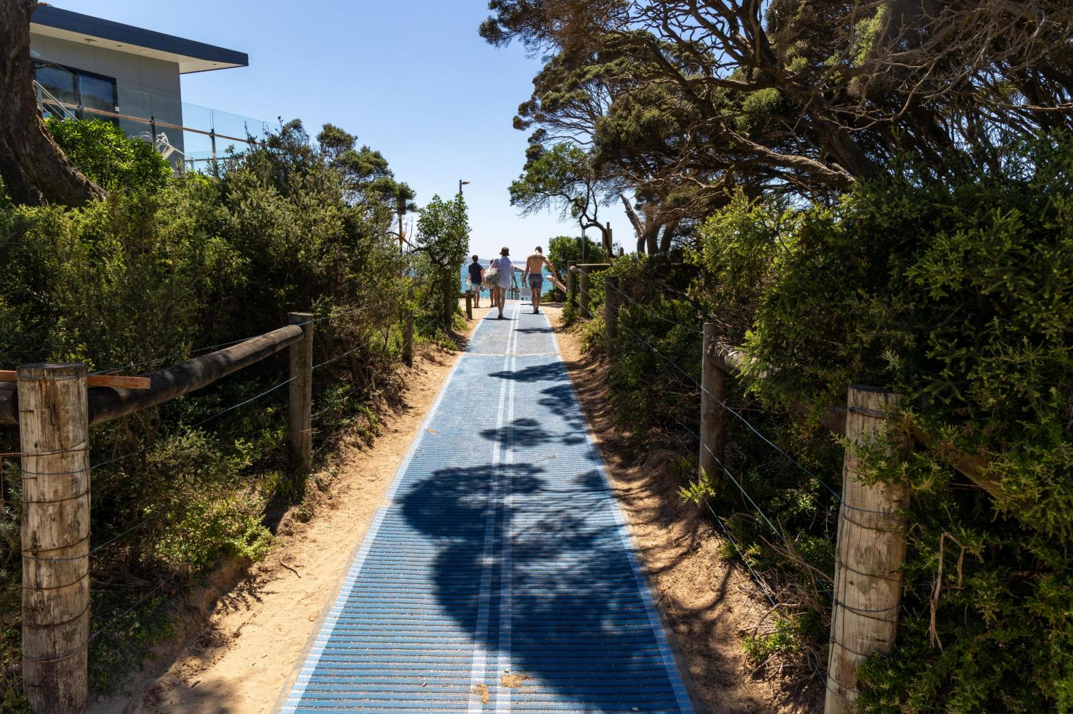
2027-2031


DRAFT
Acknowledgment of Country
Surf Coast Shire Council acknowledges the Wadawurrung People, and Gulidjan and Gadubanud Peoples of the Eastern Maar, their Elders and leaders past, present and emerging as the Traditional Owners of the skies, land, waters and sea country across our municipality.
We acknowledge their care and custodianship for more than 60,000 years, which continues today. We walk with them as we respectfully care for and tread lightly on these lands.
We also extend that respect to all First Nations people who are part of the community.
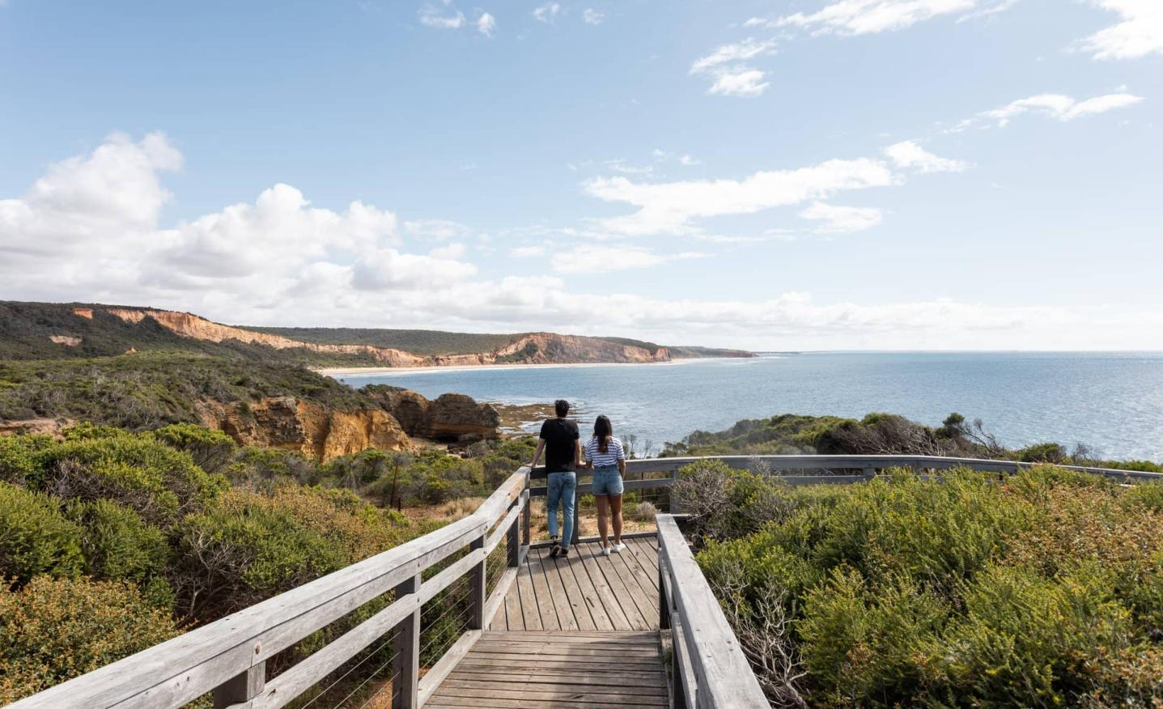

Contents

Introduction to the plan 3
About people with disability in Surf Coast Shire 7
How we talk about disability 9
What our community told us 10
Action plan focus areas 15
Why these focus areas are important 16
Our goals and how we will achieve them 21
How we will measure our success 30
Where this plan fits 31
Definitions 34
References 37

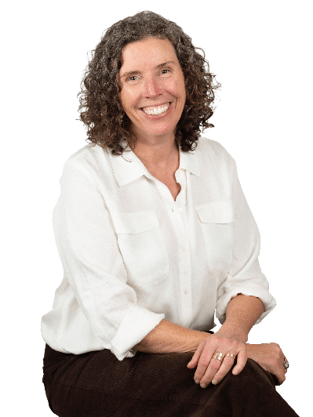
Introduction to the plan

A message from our Mayor
“Inclusive communities are healthy communities.
When people feel included, they are more likely to participate in everyday aspects of life, whether that’s education, employment, housing, or simply getting around their community. Inclusion helps everyone to live with dignity, respect and the opportunity to fulfil their potential.
Our commitment through this action plan is to continue fostering a community where people with disability feel they belong.”
– Councillor Libby Stapleton, Mayor

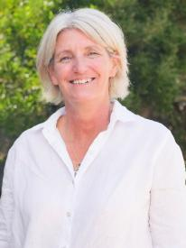
A message from our CEO
“We know that people with disability continue to face barriers that limit full participation in community life. These barriers can be physical, but they are also often found in discriminatory systems and attitudes.
Council has an important role to play identifying and removing barriers, challenging discrimination, and working alongside our community to create lasting change.
Our goal is to create environments that are accessible, inclusive and equitable for all.”
– Robyn Seymour, CEO


A message from our Disability Advisory Committee Chair
“Accessibility is not an optional extra, it is a human right and a fundamental condition of good local government. By applying the 2027-2031 Disability Action Plan, Council can ensure that pools, sporting and recreation facilities, signage, wayfinding, tourism information, programs and services can be accessed, understood and used by the widest possible range of people.
This plan is an important commitment to removing barriers and enabling people with disability to participate in Surf Coast life with dignity, choice and equality.
The Disability Action Plan takes a Universal Design approach, looking at how improved access within our communities increases participation and inclusion of people with disabilities and the broader community who benefit from accessible infrastructure and programs across our Shire."
– Tim Harte, Disability Advisory Committee Chair

Our commitment to equity and inclusion
Council is committed to equity and inclusion for all. We value the diverse skills and perspectives that people bring to our community because of their personal attributes and life experiences.
We are committed to walking alongside our community to learn and continue to create a more inclusive community.
We stand against racism and discrimination of any kind.

Our journey in disability inclusion
This plan builds on work Council has been doing for many years to improve disability inclusion in our organisation and the broader community. This has included a number of disability strategies and action plans, and the ongoing involvement of our Disability Advisory Committee, which provides lived experience advice to Council and has been running since 2002.
To view the most recent progress report on our last action plan, please view our website: Council website – Plans and strategies.
“Over the past five years, I have noticed conversations have gone from single issues to really comprehensively talking about how we get disability inclusion in all Council processes…I think we should be really proud of where we’ve come from and look to the next five years to say ‘hey we’re doing some great stuff here…although we’re not there yet’.”
- Disability Advisory Committee member 2026
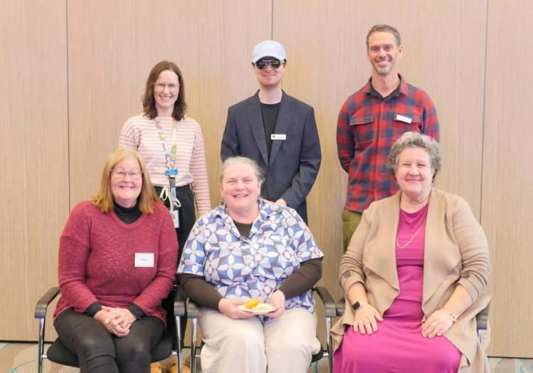
Council’s Disability Advisory Committee 2025

Learn more
To learn more about Council’s work in disability inclusion, or if you have any questions you can:
- Visit the Council website – Disability Inclusion
- Contact the Disability Inclusion Advisor on 03 5261 0600, email info@surfcoast.vic.gov.au, or lodge a request online.

About people with disability in Surf Coast Shire

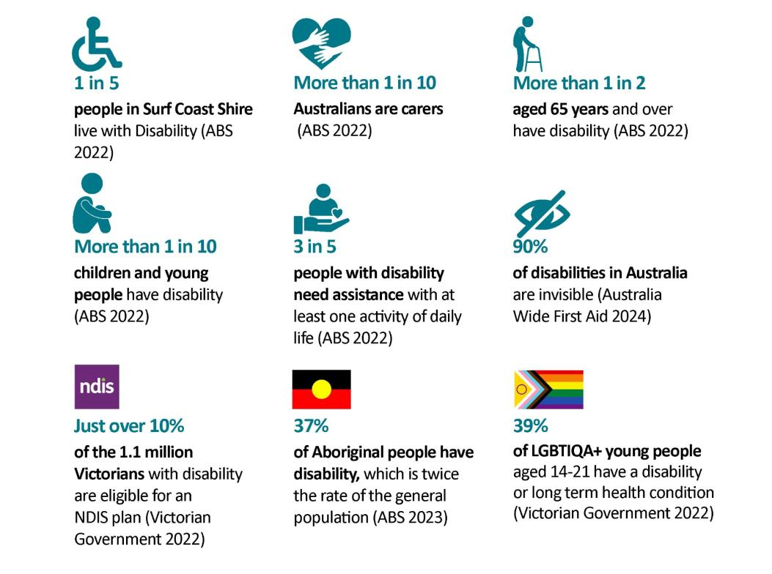
People with disability

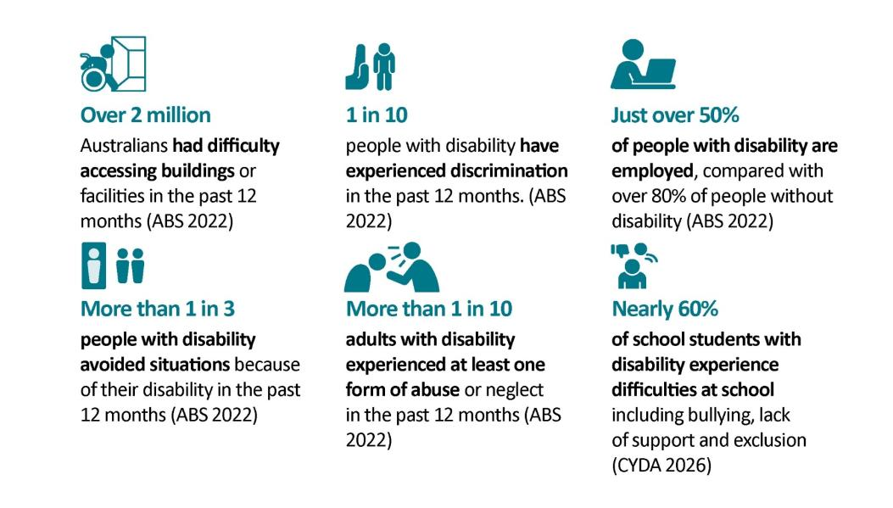
Barriers experienced by people with disability

How we talk about disability

Social model of disability
The social model sees disability as the result of the interaction between:
- people living with long-term physical, mental, intellectual or sensory differences and
- an environment filled with physical, attitudinal, communication and social barriers.
The social model implies that the environment must change to enable people living with disability to participate in society on an equal basis with others (People with Disability Australia 2026)

Person-first vs. Identity first language
In this plan we use person-first language that puts the person before their disability such as ‘person with disability’.
While some people in the disability community prefer to use person-first language, others prefer to use identity-first language such as ‘disabled person’.
Identity first language reflects how a person’s disability may be a key part of their identity and a way that they form a connection with the disability community.

Other important definitions are provided at the end of the document.

What our community told us

How did we collect feedback?
This plan was developed in 2026 using community feedback from a range of sources including:
- Council Plan survey 2025 – feedback from people with disability (41 responses) and carers (72 responses) (out of a total 858 responses)
- Surf Coast Shire Disability Advisory Committee feedback 2026
- Council staff consultation 2026
- Community feedback on the draft Disability Action Plan via survey and in person workshops 2026 (in progress)

What we heard…

Active community members
People with disability and carers are active in our local communities, and volunteer and participate in community activities and local events at a similar rate to the overall population.

Disability inclusion is a priority
People with disability make up around 20% of the population, and there is a growing population of older people in Surf Coast Shire who will acquire some form of disability as they age. Improving access and inclusion in our community assists most people, including parents with prams, older people, and people from diverse backgrounds.
Local people with disability and carers have mixed views about whether Council currently makes access and inclusion a priority, with 42% of respondents agreeing or strongly agreeing, 37% disagreeing or strongly disagreeing, and 22% reporting they were unsure.
“We are the mainstream, and should not be thought of as a minority group or an afterthought.”

Health and wellbeing outcomes
Local people with disability report worse health and wellbeing outcomes than the general population in relation to a range of issues including family violence, mental health challenges, and the use of tobacco, vaping and e-cigarettes.
People with disability also experience much higher levels of physical and mental health impacts due to climate change and climate emergencies, such as anxiety and heat related illness.
“We need more nurturing in the mental health space.”

Structural inequality and discrimination
Almost 40% of local people with disability and carers do not feel the Surf Coast Shire is a safe and equitable place. Compared to the general Surf Coast Shire community, people with disability experience almost three times the level of discrimination, almost double the level of food insecurity, and greater issues with accessing employment, moving around the community, and gender inequality.
“Public transport is not accessible for many people with disability.”
“We need to change community prejudice about mental health.”

Community attitudes and participation
Two thirds of local people with disability and carers feel that our community is inclusive. However participation in community events and activities can often depend on individual advocacy from people with disability or carers, rather than events and groups being inclusive from the start.

“People are friendly and always hello.”
“I’d love to see more free inclusive events.”
“We need more education for community members, schools and workplaces regarding kids with disabilities and neurodivergence…often these kids are labeled ‘naughty’.”

Image to come

Infrastructure gaps
Many people with disability struggle to navigate our community, and there are significant challenges in accessing footpaths, parking, transport, parking, and beaches. While some progress has been made, greater investment and long-term planning are needed to create a truly inclusive environment. 50% of local people with disability and carers feel the built and natural environment is not inclusive, while less than 40% believe it is inclusive.
“Fix the footpaths please.”
“Things are definitely headed in the right direction and it is a lot easier to go out and do things in a wheelchair. Sometimes it’s hard to access facilities when there’s a step etc.”
“We need more disability parking spaces.”
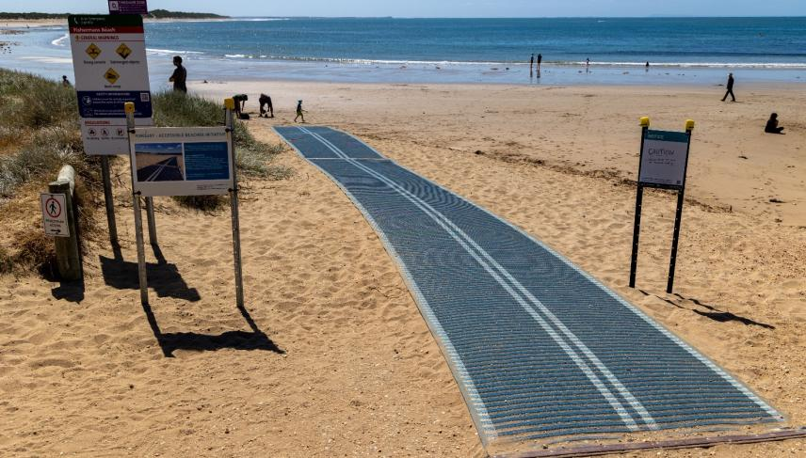
“Please make sure accessible bathrooms are situated in locations where people can also access the great trails and beaches the rest of the community gets to enjoy.”
Image: Accessible beach matting Torquay

Lack of access to local health and support services
Almost twice as many people with disability need to leave the Shire to access the health and wellbeing services they need, when compared to the general population. Particular needs are more access to local hospital, mental health, disability, and allied health services.
“I have to go outside of the shire to access support.”
“We need more services and access to mental health care.”

Challenges for Carers
Carers in our Shire also face numerous challenges including mental health challenges, gender inequality, family violence, and social isolation. Carers spoke about a lack of dedicated support, making it difficult for them to find respite or engage in social activities. There were requests for renewed focus on improving physical accessibility, enhancing public transport options, and increasing council engagement with people with lived experience of disability.
“Limited support for carers makes it extremely difficult for carers to meet, to find respite, to work and to have a fulfilling life.”

Influencing local decisions
Council’s Surf Coast Shire Disability Advisory Committee is recognised as a positive way to hear from people with lived experience of disability. However almost 50% of local people with disability and carers feel that they cannot influence local decisions that affect them.
“Council needs to improve consultation with key user groups.”
“Council are proactive in their approach and have a disability advisory committee made up of those with lived experience...well done.”

Action plan focus areas
Our disability access and inclusion work over the coming five years will be focused on the following five areas.

Focus area |  |  | What this means for people with disability and carers
 | Organisational Leadership |  | Council makes access and inclusion a priority.
 | Accessible and inclusive places and spaces |  | People with disability can use public places.
 | Inclusive communication and services |  | People with disability can find information and use Council services.
 | Community attitudes and participation |  | People with disability feel welcome and can take part.
 | Inclusive employment and volunteering |  | People with disability can work or volunteer with Council.

Why these focus areas are important

Organisational Leadership
Council recognises people with disability as valuable members of our community. We have a shared responsibility with other levels of government to build a community that is accessible and inclusive for everyone. This is a human rights obligation and a legal requirement in Australia.
“We need to embed disability inclusion in everything council does and in every person. So it's not just the responsibility of one staff member, but it's the responsibility of everyone.”
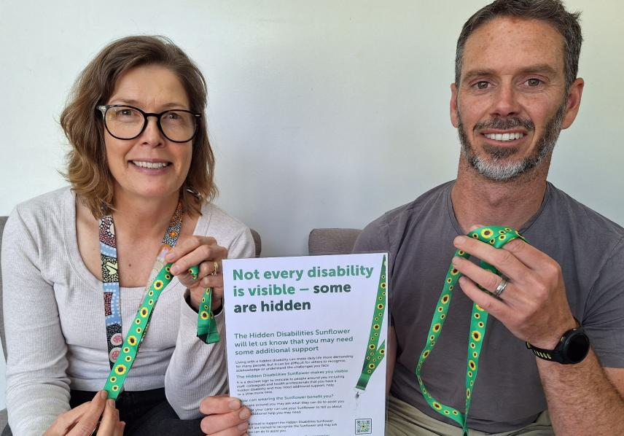
- Disability Advisory Committee member 2026
Image: Maternal and Child Health Nurse Narelle Steel with Councillor Leon Walker launching the Hidden Disability Sunflower 2025

Accessible and inclusive places and spaces
People with disability experience ongoing barriers to access and inclusion in public places and spaces. The principles of Universal Design suggest that making public places accessible and inclusive is good for everyone in our society, whether you are a parent with a young child in a pram, an older person, or someone with a temporary injury.
“Making places more accessible doesn't just benefit people with disability. It benefits everyone.”
- Disability Advisory Committee member 2026
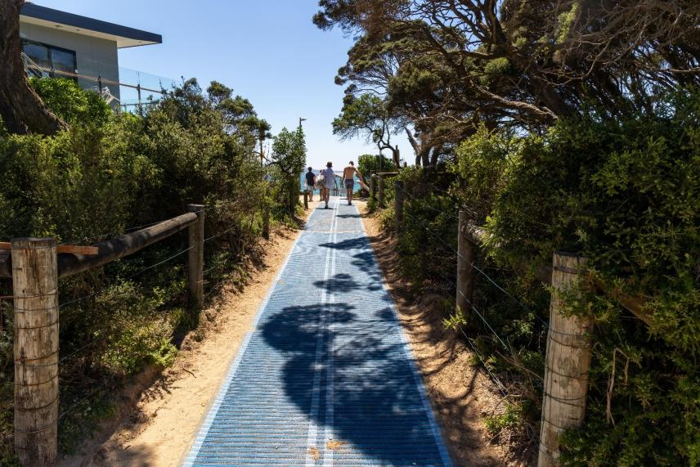
Image: Accessible beach matting Anglesea 2025

Inclusive communication and services
Inclusive communication and accessible public services are essential to allow people with disability to access information, exercise their rights, participate in community life, and use services independently and safely.
“Disability inclusion has to be there from the start. Each department and each project. And make sure that you do it every time.”
- Disability Advisory Committee member 2026
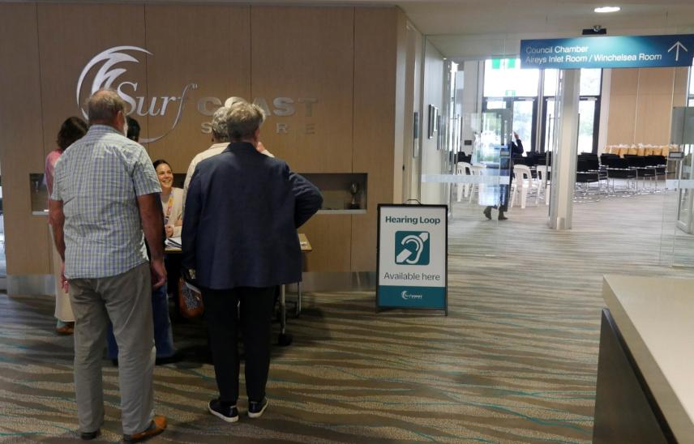
Image: Hearing loops signage at Council’s Local Legends Awards 2026

Community attitudes and participation
Unwelcoming community attitudes can be a major barrier to people with disability participating in our community. Improving attitudes towards people with disability is important because this builds inclusive communities where everyone can participate and thrive.
“Traditionally, disability has been perceived as a negative, as something to be ashamed of, or something that limits people. But disability pride rejects that idea. Disability pride is a direct challenge to the low expectations that the world can have of people with disability.”
– Youth Disability Advocacy Service 2026

Inclusive employment and volunteering
There is strong evidence that diverse and inclusive workplaces improve organisational performance through:
- better decision-making by using a wider range of perspectives
- improved problem solving and innovation
- attraction and retention of talented employees
- better understanding and responses to diverse communities.
“[People with disability] deserve the choice like everybody else to get out there and find employment. And it can be a pretty brutal landscape sometimes for a lot of people to get out there and get those opportunities that they deserve to have the choice and control over their life if they want to work.”
- Dylan Alcott AO, a witness at Public hearing 31, ‘Vision for an inclusive Australia’ (Disability Royal Commission 2023)

Our goals and how we will achieve them
The following table outlines the goals we aim to achieve in each focus areas, and examples of the actions we will take. A detailed workplan will be created to support implementation for each department within Council.
1. Organisational Leadership

Council makes access and inclusion a priority.
We will achieve this by (goals) | We will (example actions) | Area responsible
- Building staff capacity to support disability inclusion through disability awareness and Universal Design training. | - Implement mandatory online training in disability awareness for all staff.  - Provide disability awareness training to Councillors. | People and Culture /  Governance
- Embedding disability access and inclusion in Council policies, procedures, processes, guidelines and practice. | - Create a Universal Design policy to guide all Council programs, projects and services. | Community Health and Development
- Recognising and celebrating people with disability in our local community. | - Celebrate International Day of People with Disability annually with a Council endorsed event. | Internal Events /  Communications
- Focusing on people with disability in the implementation of Council’s Municipal Public Health and Wellbeing Plan to improve the health and wellbeing of people with disability and carers. | - Advocate and partner to increase health services across the Shire.  - Increasing community mental health awareness and promoting local mental health services. | Community Health and Development

2. Accessible and inclusive places and spaces

People with disability can use public places.
We will achieve this by (goals) |  | We will (example actions) |  | Area responsible
- Improving accessibility of existing infrastructure across the Shire | - Deliver ongoing funding and implementation of Disability Discrimination Act compliance project to improve physical accessibility of Council facilities.  - Source funding to implement the accessible carpark audit 2022 to upgrade accessible carparks to current standards.  - Source ongoing funding for footpath upgrades to improve safety and accessibility of our townships. |  | Design and traffic /  Community recreation /  Social infrastructure /  Asset renewal
- Ensuring all new social infrastructure projects and upgrades use Universal Design principles to increase inclusion to the greatest extent possible. | - Create design guidelines for all social infrastructure types to guide universal design objectives for all Council facilities, open spaces and trails, drawing on Design for Everyone Guide. |  | Social Infrastructure
- Embedding universal design principles in Council’s strategic planning to make our community more accessible and inclusive for people with disability. | - Consult with people with lived experience of disability on the Torquay commercial precinct project, and ensure access consultant is involved in design phases of the project. |  | Strategic Planning /  Economic Development
- Ensuring Council’s statutory planning processes improve accessibility for people with disability to the greatest extent possible. | - Explore best approach for internal decision making when accessibility requirements (DDA) compete with other priorities such as heritage and environmental protections. |  | Statutory Planning /  Social Infrastructure /  Community Health and Development
- Supporting partners in continuing to improve beach accessibility across the Shire. | - Provide regular advice to GORCAPA and other partners on improving beach accessibility.  - Maintain website information on beach access.  - Ongoing maintenance and support for Council’s beach wheelchair managed by Go Ride A Wave Torquay. |  | Community Health and Development
- Advocating to State and Federal governments to improve public transport across the Shire. | - Include public transport in Council’s annual advocacy priorities. Include focus on accessible transport such as accessible buses. |  | CEO Office /  Integrated Planning
- Ensuring people with disability are involved and their needs addressed in climate action and environmental projects. | - Support people with disability to adapt to the changing climate including engaging them in the rollout of The Adaptation Game. |  | Climate and Environment

3. Inclusive communication and services

People with disability can find information and use Council services.
We will achieve this by (goals) |  | We will (example actions) | Area responsible
Communication
- Improving accessibility and inclusiveness of publications, website and marketing. | - Create Easy Read documents for important Council information.  - Work with Council web authors to make web-based information simpler and easier to understand. |  | Communications
- Improving staff knowledge and practice about inclusive and accessible communication. | - Deliver regular accessible communication training for staff. |  | Communications
- Evaluate use of existing access maps and explore community need for updated maps. | - Evaluate use of existing accessible township maps and need for updating these maps through community engagement. |  | Community Health and Development
Services
Increasing access and inclusion in key Council services including:
- Early Years and Child and Family Health | - Source funding to upgrade Council kindergartens to DDA compliance.  - Monitor and evaluate Maternal Child Health service implementation of Hidden Disability Sunflower. |  | Early Years /  Child and Family Health
- Youth | - Create access keys, sensory maps and social stories for key youth programs and events. |  | Community Health and Development
- Positive Ageing | - Ongoing collaboration between Positive Ageing Advisory Committee and Disability Advisory Committee. |  | Community Health and Development
- Waste | - Investigate accessible options for hardwaste collections. |  | Waste
- Customer Service | - Rollout Hidden Disability Sunflower program to key Council Services including Customer Service. |  | Customer Service
- Emergency Management | - Evaluate accessibility of Emergency Relief Centres, and ongoing work to increase inclusion e.g. sensory supports and quiet spaces. |  | Emergency Management
- Rates | - Review accessibility of rates notices and hardship policy. |  | Rates
- Rangers | - Create Easy English information for pet owners. |  | Rangers
- Planning | - Collect experiences of customers with disability in bi-annual customer experience survey, and use to implement disability inclusion improvements. |  | Planning

4. Community attitudes and participation

People with disability feel welcome and can take part.
We will achieve this by (goals) |  | We will (example actions) | Area responsible
Community attitudes
- Increasing understanding and support for people with invisible disability through the Hidden Disability Sunflower program: within Council and community-wide. | - Rollout the Hidden Disability Sunflower across Council and community. |  | Economic Development /  Community Recreation /  Health and Wellbeing
- Improving disability awareness in community groups and community leaders through training and events. | - Provide community disability awareness training sessions for community groups and volunteers. |  | Volunteering
- Increasing community understanding of disability inclusion through social marketing campaigns. | - Featuring people with disability in Council media campaigns such as ‘heart of the community’, and for disability focused events such as International Day of People with Disability. |  | Communications
Community participation
Ensuring events, activities and programs are inclusive for people with disability including:
- Ensuring Council events and activities are inclusive and accessible for people with disability. | - Work with Council event organisers to ensure all Council adopted events include inclusive features such as quiet spaces, hearing loops, social stories, and access maps. |  | Internal events
- Supporting community events and activities to be more inclusive for people with disability. | - Continue to provide free hire of Hearing loops and noise cancelling headphones to community groups and event organisers. |  | Events
- Working with partners to make tourism more inclusive for people with disability in Surf Coast Shire. | - Continue to distribute information on accessible tourism experiences with partners, to be published on the Visit Great Ocean Road – Accessibility website. |  | Tourism
- Ensuring sport and recreation opportunities in Council facilities are inclusive for people with disability. | - Work with Aquatic Centre operator on sensory friendly times for Winchelsea and Torquay pools. |  | Community Recreation
- Ensuring Council’s community development work is inclusive for people with disability | - Review Council’s work with community houses, men’s and women’s sheds, and community planning processes to increase disability inclusion outcomes. |  | Community Health and Development
- Improving intersectional understanding and support for First Nations people with disability. | - Provide training for Disability Advisory Committee to improve understanding of lived experience of First Nations people with disability. |  | First Nations
- Improving disability inclusion in events and activities delivered by Council grant recipients. | - Update inclusive event checklist and guidelines to include resources and templates for social stories, event booking pages, event invitations and access maps. |  | Grants
- Supporting local businesses to become more accessible and inclusive. | - Include disability inclusion guidance in Concierge Toolkit for new businesses.  - Continue to promote and support accessible café and restaurant online map on Council website. |  | Economic Development
Community engagement
- Engaging with community members with disability and carers on key Council projects, processes and programs. | - Continue to support function of the Disability Advisory Committee including 4-6 meetings per year to gain lived experience feedback on Council projects, programs and policies. |  | Community Engagement /  Community Health and Development
- Improving Council’s community engagement processes and delivery to become more inclusive for people with disability. | - Create inclusive community engagement resources and deliver training for staff who deliver community engagement. |  | Community Engagement /  Community Health and Development
- Ensuring data on disability status is collected in anonymous Council surveys and used to improve outcomes for people with disability. | - Continue to include identity questions including people with disability and carers in all Council surveys and data collection. |  | Community Engagement

5. Inclusive employment and volunteering

People with disability can work or volunteer with Council.
We will achieve this by (goals) |  | We will (example actions) | Area responsible
Employment
- Improving physical accessibility of Council workplaces. | - Undertake an access audit of all Council workplaces.  - Upgrade staff entrance Torquay Civic Office to meet accessibility standards. |  | People and Culture /  Operations
- Continuing to improve Council’s recruitment processes to become more inclusive for people with disability. | - Participate in the Job Access National Disability Recruitment Coordinator 12-month partnership program to help drive Council’s disability initiatives and build disability confidence. |  | People and Culture
- Improving knowledge and capacity of supervisors to better support staff with disability. | - Deliver annual workplace adjustment and disability inclusion training for supervisors. |  | People and Culture
- Increasing knowledge and capacity in disability awareness and inclusion for all staff (See priority 1) | - See Objective 1.1 – all staff training. |  | People and Culture
Volunteering
- Continuing to improve volunteer recruitment to be more inclusive for people with disability and carers. | - Update volunteer policy and procedure to include inclusive recruitment processes and Workplace Adjustment Policy. |  | Volunteering
- Improving support for Council volunteers with disability. | - Review site induction questions for new volunteers to include Workplace Adjustment Policy. |  | Volunteering
- Increase targeted volunteering opportunities that are accessible and inclusive for people with disability | - Work with staff to create specific volunteer opportunities for people with disability. |  | Volunteering

How we will measure our success

Progress on actions
We will measure the implementation of the plan:
- mid-way through the plan (2028)
- at the end of the plan (2031).
We will review the plan with staff and the Disability Advisory Committee, and provide a progress report to the community. At our mid-way review, we may also update the Action Plan to address any new needs, gaps or opportunities.

Impact of the plan
We will measure the broader impact of the plan on disability inclusion through the Integrated Community Wellbeing Plan’s monitoring and evaluation plan.

Where this plan fits

International, national, and state frameworks
Council’s Disability Action Plan fits within a number of international, national and state frameworks and laws, that aim to make sure the rights of people with disability are upheld and protected.
International, national and local context
  International | United Nations Convention on the Rights of Persons with Disabilites
  National | Australia’s Disability Strategy (2021-2031) |  | National Agreement on Closing the Gap |  | Disability Discrimination Act 1992
 | NDIS |  | Information Linkages and Capacity Building program |  | Royal Commission into Violence, Abuse, Neglect and Exploitation of People with Disability
  Victorian | Disability Act 2006 (Vic) | The Victorian Aboriginal Affairs Framework 2018-2023 |  | Equal Opportunity Act 2010 |  | Charter of Human Rights and Responsibilities Act 2006 (Vic)
 | Inclusive Victoria: State disability plan (2022-2026)
  Local government | Surf Coast Shire Disability Action Plan (2026-2030)

The Victorian Disability Act 2006 requires all local governments to have a Disability Action Plan.
The Disability Discrimination Act 1992 requires all local governments to provide inclusive and accessible environments for all, including employment, education, public services, and public spaces.

Council strategies and plans
Through the delivery of a number of plans, Council works to create safer, more welcoming and inclusive places, spaces, programs and services for all. Relevant plans include the Council Plan and Municipal Public Health and Wellbeing Plan, and the Integrated Community Wellbeing Action Plan.

Council Plan and Health and Wellbeing Plan
This plan will help us deliver Council’s overarching Council Plan and Health and Wellbeing Plan 2025-2029.
The Council Plan has five key directions:
- Assets and Infrastructure
- Climate and Environmental Leadership
- Community Wellbeing
- High Performing Council
- Sustainable Communities
The Health and Wellbeing Plan has five priority areas for improving the health and wellbeing of community members in the Surf Coast Shire:
- Increase Healthy Eating and Active Living
- Advance Gender Equity and Address Family Violence
- Improve Mental Health and Social Connection
- Reduce Harm from Alcohol and Vaping
- Tackle the Impacts of Climate on Health

Integrated Community Wellbeing Action Plan
This Disability Action Plan is embedded in our Integrated Community Wellbeing Action Plan 2026-2030, which brings together all areas of diversity and inclusion at Council. This integrated approach supports us to better address the intersectional experiences of people with disability and carers, which means thinking about how disability can be layered with other identities such as gender, race, sexuality, and age.
The goals of the integrated wellbeing plan include:
- Community activation: Place-based activation; working in specific communities, with local people, in ways that reflect local identity, needs, culture and strengths.
- Social Equity & Inclusion: Ensuring everyone has a fair opportunity to participate, contribute and belong, regardless of their background, identity or circumstances.
- Capacity Building & Advocacy: Strengthening the capacity of communities, organisations and systems to lead, participate and respond to local needs, while advocating for improved outcomes.
- Insights & Evaluation: Understanding community needs and experiences, and using evidence, data and learning to improve outcomes and inform decision-making.

Definitions

Disability
People with disability include those who have long-term physical, mental, intellectual, or sensory impairments, which in interaction with various barriers may limit their full and effective participation in society on an equal basis with others (United Nations Convention on the Rights of Persons with Disabilities 2006).
Disability can be temporary or permanent, something acquired or something that was present from birth.

Carer
A carer is someone who provides unpaid care and support to family members and/or friends with a disability, mental illness, substance addiction, chronic health issue or an older person with care needs (Carers Victoria 2026).

Neurodivergence
The natural diversity of human brains meaning that everyone has a unique way of thinking, feeling and functioning. Neurodivergence means that some people think, feel and function in ways that are considered less common, as opposed to people who are neurotypical. (Australian Institute of Family Studies 2025).

Ableism
Ableism is discrimination or prejudice towards people with disability. It can be described as the systemic and interpersonal exclusion and oppression of people with disability. (Victorian Government 2022).

Intersectionality
Ableism interacts with other forms of discrimination, such as gender inequality, racism, homophobia, biphobia, transphobia and ageism. This creates multiple and intersecting forms of systemic discrimination for Aboriginal people, women, LGBTIQA+ people, multicultural people, older people and young people. (Victorian Government 2022).

Diversity
Diversity is about what makes each of us unique and includes our backgrounds, personality, life experiences and beliefs, all of the things that make us who we are. It is a combination of our differences that shape our view of the world, our perspective and our approach. Diversity is also about recognising, respecting and valuing differences based on ethnicity, gender, age, race, religion, disability and sexual orientation. (Victorian Government 2023).

Equity
Equity is about everyone achieving equal outcomes. We all have the same value and deserve a good life, but we all start from a different place. We are also all wonderfully different and experience the world in our own unique way. It's because of these differences that we sometimes need to be treated differently for us all to live safely, healthily, happily. This means that we need to look at what individual people and communities need in order to achieve equity. (Australian Human Rights Commission 2026).

Inclusion
Inclusion occurs when people feel, and are, valued and respected. Regardless of their personal characteristic or circumstance, and where they:
- have access to opportunities and resources
- can contribute their perspectives and talents
- have a sense of belonging.
(Victorian Government Diversity and Inclusion Strategy 2023).

Universal Design
Universal Design is the design of an environment, or any building, product, or service in that environment, so that it can be accessed, understood and used to the greatest extent possible by all people regardless of their age, size, ability or disability. An environment should be designed to meet the needs of all people who wish to use it. This is not a special requirement, for the benefit of only a minority of the population. It is a fundamental condition of good design. (Centre for Excellence in Universal Design 2026).

References
Australian Bureau of Statistics (ABS 2022). Disability Ageing and Carers Australia Summary. ABS website - Disability Ageing and Carers.
Australian Bureau of Statistics (ABS 2023). National Aboriginal and Torres Strait Islander Peoples – Disability and Unpaid Care Latest Release. ABS website - National Aboriginal and Torres Strait Islander Peoples - Disability and Unpaid Care.
Australian Governments (2020) National Agreement on Closing the Gap. Canberra: Commonwealth of Australia. National Agreement on Closing the Gap.
Australian Government (2021) Australia’s Disability Strategy 2021–2031. Canberra: Australian Government. Australia’s Disability Strategy 2021–2031
Australian Institute of Family Studies (2025). Defining key terms relating to neurodivergence. AIFS website - defining neurodivergence.
Australian Human Rights Commission (2026). Resources for teachers and students: Equality and equity. AHRC website - classroom resources on equality and equity.
Carers Victoria (2026). Am I a carer? Carers Victoria website - Am I a carer.
Centre for Excellence in Universal Design (2026). About Universal Design. Centre for Excellence in Universal Design website - About Universal Design.
Children and Young People with Disability Australia (CYDA 2026). Key statistics on children and young people with disability. CYDA Key Statistics.
Commonwealth of Australia (1992) Disability Discrimination Act 1992 (Cth).
Royal Commission into Violence, Abuse, Neglect and Exploitation of People with Disability (2023) Final report. Disability Royal Commission – Final Report.
Royal Commission into Violence, Abuse, Neglect and Exploitation of People with Disability (2023). A brief guide to the Final Report (2023). Disability Royal Commission website - Brief Guide pdf.
People with Disability Australia (2026). Models of disability. People with Disability Australia website - Models of Disability.
Surf Coast Shire Council (2025). Council Plan and Health and Wellbeing Plan 2025-29. Surf Coast Shire Council website - Council Plan.
Surf Coast Shire Council (2025). Disability and Carers – Our Focus Our Future community engagement 2025 data report. Internal report.
Surf Coast Shire Council (2025). Council Plan: Minority and vulnerable groups within Surf Coast Shire communities. Internal report.
United Nations (2006) Convention on the Rights of Persons with Disabilities. United Nations – Convention on the Rights of Persons with Disabilities.
Victorian Government (2006) Charter of Human Rights and Responsibilities Act 2006 (Vic). Victorian Legislation – Charter of Human Rights and Responsibilities Act 2006.
Victorian Government (2006) Disability Act 2006 (Vic). Victorian Legislation – Disability Act 2006.
Victorian Government (2023). Diversity and Inclusion Strategy 2023: What do we mean by diversity and inclusion. Victorian Government website - Diversity and Inclusion.
Victoria (2010) Equal Opportunity Act 2010 (Vic). Victorian Legislation – Equal Opportunity Act 2010.
Victorian Government. Inclusive Victoria State Disability Plan 2022–26 (2022). Victorian Government website - State Disability Plan.
Victorian Government (2018) Victorian Aboriginal Affairs Framework 2018–2023.
World Health Organization. Social determinants of health. World Health Organisation website - Social determinants of health.
Youth Disability Advocacy Service (YDAS 2026). What is disability pride? YDAS website - Disability Pride.

