Camp Road Anglesea, cycle path options Communications and Engagement Results
May 2026
Contents
Purpose 2
How we engaged 2
How engagement influenced the outcome 2
Your Say survey results 3
How important is a bike path along Camp Road, Anglesea (from the shops to the school)? 3
How often do you ride a bicycle / e‑bike or scooter / e-scooter? 4
What issues do you notice when cycling or walking on Camp Road, Anglesea? 5
What bike and pedestrian infrastructure would you like to see on Camp Road, Anglesea, in the future? 6
If you don’t like either option, please tell us why? What would you like to see? 7
If your preferred option was built, would you be more likely to walk or cycle along Camp Road, Anglesea? 8
Do you have any other comments about creating a cycle path along Camp Road, Anglesea? 9
Demographics 10
Response to key themes raised through engagement 12
Next steps 13

Purpose
The purpose of the engagement was to hear which cycle path option the community most preferred along Camp Road. The engagement was open from Tuesday 31 March to Monday 11 May 2026.
During this time we collected the following statistics:


How we engaged
We received feedback from community via:
- an online survey on Council’s Your Say page
- we had 23 reactions across Council’s Facebook and Instagram posts including shares to other Facebook pages.
To get the word out about the project and encourage feedback we prepared the following communications:
- Media release (1 April).
- Social media posts: a primary post (8 April) and a reminder post (8 May).
- Two decals were stuck on the footpath along Camp Road.
- Email sent to school for their newsletter.
- Emails sent to DEECA
- Letter sent to residents on Camp Road and surrounding area.
- Mention in Mayor’s Column in the Surf Coast Times (17 April)
- Taken to Anglesea Community Plan meeting (5 May)

How engagement influenced the outcome
Council thanks the community for their feedback and we have considered and assessed all aspects that have been raised. Overall the feedback reflects that the community strongly supports the provision of cycling facilities along Camp Road and given that there has been equal support for the two proposed options, a multi-criteria assessment has been completed, by an external consultant, which indicates that Option 1, on-road bicycle lane, is the preferred option and gives a higher benefit to cost ratio.
In response to the concerns raised regarding separation between cyclist and through traffic, physical separators will be used where possible will be utilised to separate cyclist from the through traffic and where it isn’t possible line marked separators will be used.
The community feedback has identified that the Bingley Parade is currently used, by some, as an alternative cycling connection rather than the use of Camp Road, due to the lower traffic volumes. Given that this project requires grant funding to proceed, an interim proposal is to promote and make safer the use of Bingley Parade as a cycling connection. This may include works such as directional signage for cyclists, etc.
We had considered upgrading of the footpath along Camp Road to a shared path for both cyclist and pedestrians, but have concluded that the option is not suitable in this instance. There is a significant cost increase for this option due to the required earthworks, regrading of driveways, the widening of existing paths and construction of new sections. This option also requires greater vegetation loss and creates an interaction between cyclist and pedestrians that has been raised as a concern based on the feedback.
Additionally, we have received blackspot funding for Anglesea town centre that includes provision of a wombat crossing and mid-block raised safety platforms along Camp Road as well as the reduction of speed limits through the surrounding streets, that will increase safety in the area for both road users and pedestrians, through the reduction of speed.

Your Say survey results
“Our community loves any cycling infrastructure that supports bike riding to feel safe.”

We had 104 contributions to the survey. Most are supportive of a cycle path as a concept, driven by safety for school children and the desire for safer cycling options. Opposition exists but is small, mostly focused on route preference or concerns about traffic rather than rejecting the idea of bike infrastructure altogether.

How important is a bike path along Camp Road, Anglesea (from the shops to the school)?
Most people think a bike path on Camp Road is important. Nearly 60% rated it as highly important.
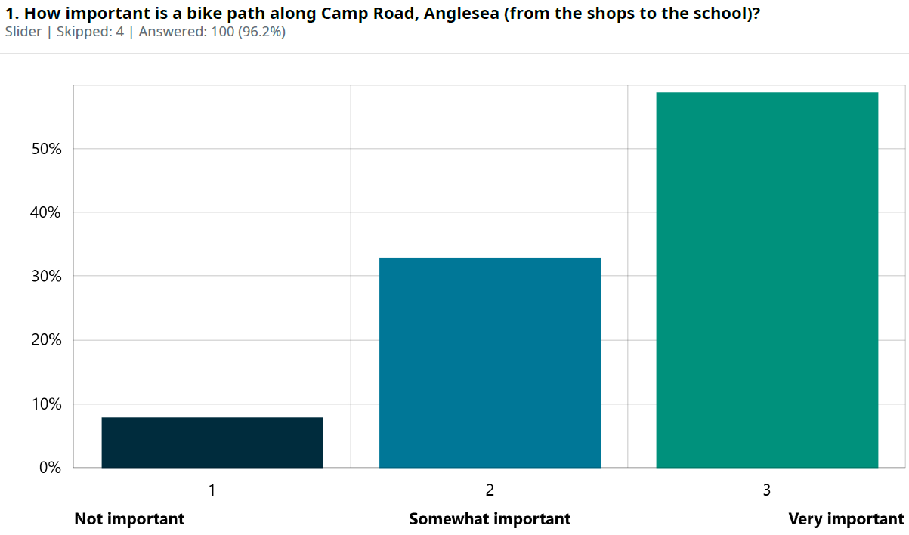

“Very popular cycle route for school students, most of whom currently ride on the pavement. A dedicated bike path will be a much better solution.”

The comments section for this question highlights that on balance the majority sentiment is supportive, driven by safety for school children and the desire for safer cycling options. Opposition exists, mostly focused on route preference or concerns about traffic rather than rejecting the idea of bike infrastructure altogether.
Most people feel a bike path along Camp Road is important because so many children ride to and from school and the current mix of narrow footpaths, fast-moving traffic and busy drop off times makes the route feel unsafe.
Respondents also raised broader safety concerns for all users, including elderly pedestrians, and would like a bike path to reduce conflict between bikes, cars and walkers while supporting more active travel.
Some respondents support safer cycling but question whether Camp Road is the right location, preferring alternatives like Bingley Parade or different designs such as on-road lanes or fully separated paths.
A smaller group is concerned about traffic flow and the narrow width of Camp Road, especially during holiday periods, while a minority believes a bike path is unnecessary or that existing routes are sufficient.
Others highlighted other needs like more footpaths, better connections and more cycling infrastructure across Anglesea. Overall, the sentiment leans toward supporting safer cycling (particularly for school children) while also reflecting differing views on design, alignment and broader infrastructure priorities.

How often do you ride a bicycle / e‑bike or scooter / e-scooter?
More than half of respondents ride a bike, e-bike or scooter at least weekly, with 18% riding daily and 36% riding 2–3 times a week. Only about a quarter said they don’t ride regularly. This suggests that cycling is a common activity in Anglesea and that safe infrastructure is relevant to many respondents.
“Protecting students and families travelling to school should take priority for safety and promoting exercise and sustainable travel”

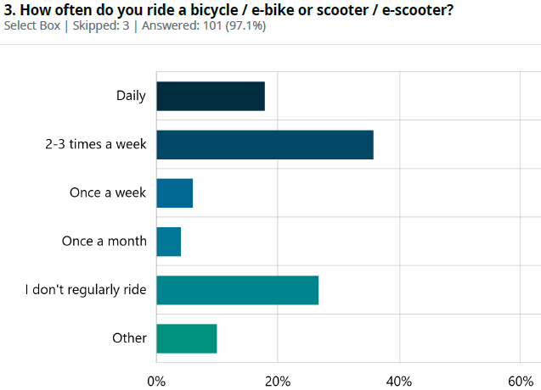

What issues do you notice when cycling or walking on Camp Road, Anglesea?

The results show that people experience several issues when walking or cycling on Camp Road, with the most common being a lack of cycling facilities (63%). Many also raised concerns about traffic speed and the number of vehicles, each selected by around 40% of respondents. A similar proportion said there are not enough safe crossing points, while one in five noted potholes or poor road surface. Another quarter listed ‘Other issues’, which often relate to pedestrian safety, driveway conflicts and seasonal congestion.

“So many cars parked on the road side now and heavy vehicles doing house building works”

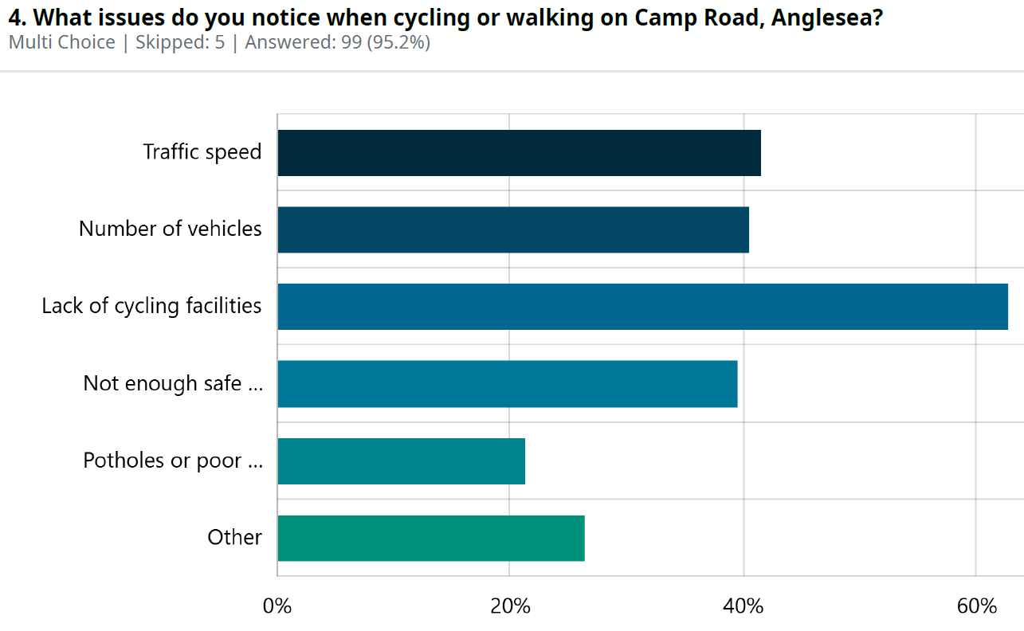

Cycling and walking issues on Camp Road centre mostly on safety, with many people highlighting the lack of a footpath, narrow paths, and frequent conflict between walkers, bikes and cars. Others pointed to heavy traffic, construction trucks, poor visibility and congestion during holiday periods, all of which make the road feel risky for less confident riders and pedestrians.
Several respondents described the current layout as cramped and unsafe, particularly near driveways, while a smaller group said they experience no problems and feel Camp Road is already safe.
Overall, the sentiment reflects a mix of safety concerns, infrastructure gaps and differing views on whether improvements such as a separated bike path or footpath upgrades are needed.
“I ride along Camp Rd and then along Bingley to get to the beach. No issues.”

What bike and pedestrian infrastructure would you like to see on Camp Road, Anglesea, in the future?

The results show that the two proposed designs were almost equally supported, with Option 1 (protected bike lanes on the western side) and Option 2 (a wider shared path transitioning to a protected lane) receiving very similar average rankings. Option 1 was only slightly preferred overall. At the same time, 33 respondents (about one-third of all participants) said they didn’t like either option, indicating a significant group who want a different approach or have concerns about both designs.

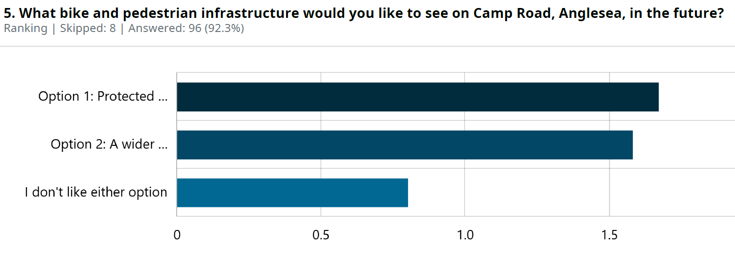
Option 1: Protected bike lanes on the western (school side), keeping the existing footpath.
Option 2: A wider shared path on the western (school side) from town centre to Agnes Lane, which would then transition into a section of protected on-road bike lane.

While the two proposed designs were almost equally supported, the community’s descriptive feedback helps explain why opinions were so close. Many people value safer cycling infrastructure, especially for children and regular riders, which lifted support for both options. At the same time, a significant portion of respondents (roughly one-third) didn’t like either option, and this aligns with earlier concerns about protecting pedestrians, especially older people and those with disabilities, and avoiding shared paths that reduce footpath safety.

“Near-traffic bike lanes are inconsistent and often dangerous. I would rather a culture of safe on-road cycling.”
“Anything that protects cyclists from cars, young and old. All ride here in Anglesea”

The close ranking also reflects the tension seen in descriptive comments. People want safer cycling routes, but they also want to preserve safe, dedicated space for walkers, avoid worsening traffic issues, and ensure any design fits the character and constraints of Camp Road.
“I want Anglesea to stay as it is. Why do we still have to keep finding things to change. Teach bike riders the bike laws and the drivers the same. We have not had a bike lane here ever and we do not need one.”

The respondents are broadly supportive of improvements, but divided on how to achieve them, with advocates for both cycling safety and pedestrian protection.

“I don’t think either option adequately addresses the issues.”

If you don’t like either option, please tell us why? What would you like to see?
Preference for routing bikes along Bingley Parade
Respondents felt Bingley Parade is already the safer, calmer and more scenic route for school riders and families. They noted it has fewer driveways, less traffic, and is already well-used. Many suggested that promoting or upgrading this route would be more effective and less disruptive than building bike lanes on Camp Road.
“Moving the bike routes to Bingley Pde is more sensible and less impact on Camp Rd residents. I already see school children choosing to ride all the way along Bingley Pde to get to school and it works well. If the route was promoted then it would be the logical route.”
Desire for fully separated bike and pedestrian spaces
Some people wanted complete separation between walkers, cyclists and cars, rather than shared paths. They argued that shared paths create conflict and that protected, dedicated bike lanes or off-road trails would offer the safest long-term solution.
“I'd like to see full separation from all modes of traffic.”
Concerns about parking loss, narrow road width and traffic impacts
A recurring theme was the need to maintain parking for residents and manage Camp Road’s limited width. People worried that removing parking or narrowing the road would make traffic worse, particularly in summer.
“We can not take away any parking along camp road. I have ridden along camp road in its current state with absolutely no issue or need for change.”
Requests for clearer information and better planning
Several respondents said they struggled to understand the options without maps, diagrams or clearer explanations. They wanted more detail about where lanes would start and end, how much parking would be removed, and what “protected” or “shared” means. Some felt the options were too narrow or didn’t consider the full range of users.
“It would be much easier to comment on this if there was a diagram of the two options.”
Alternative ideas for safer travel
Respondents suggested additional or different improvements, such as safer crossings at Kenneth Street, traffic-calming measures, warning lights at school times, or an off-road trail through Coogoorah Park and along the river. These ideas reflect a desire for a broad approach to safety rather than a single path.
“A third option of providing an exciting &/or interesting bike trail along the river adjacent to the gravel roads intersecting with tracks through the Coogoorah park and a “future” path along Betleigh street. Would provide for a non invasive option that removes all the safety exposures.”
Views that no change is needed
A smaller group opposed any new infrastructure, saying Camp Road works well as it is, that existing routes are sufficient, or that money should be spent elsewhere. Some felt changes would unnecessarily alter the character of Anglesea.
“What about the route that many cyclists already use, from Agnes Lane to Camp Rd via Bingley Pde and Wilkins St?
There is already a shared zone 20kph speed limit (not enforced) in place, less traffic, less driveways to cross over and much more scenic than Camp Rd.”

If your preferred option was built, would you be more likely to walk or cycle along Camp Road, Anglesea?

Most respondents said they would be more likely to walk or cycle on Camp Road if their preferred option were built. A further 28% said it wouldn’t change their behaviour, suggesting they already walk or ride, or that other factors influence their choice. Only 6% said “No,” and a small number were unsure or gave another answer. Improved infrastructure has the potential to increase active travel for a significant portion of the respondents.

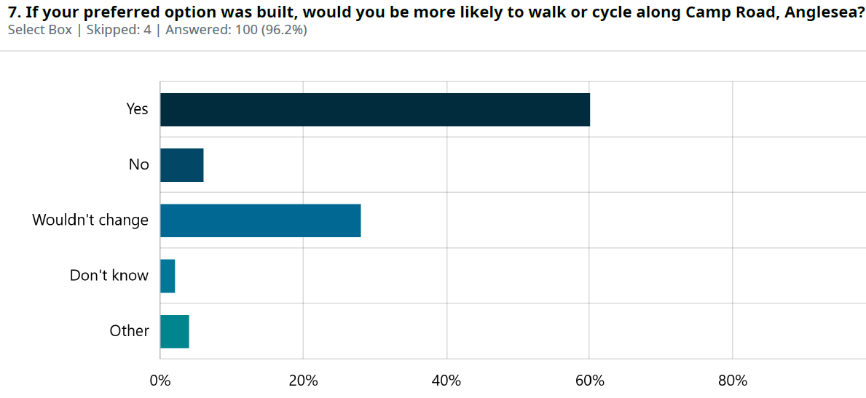

Do you have any other comments about creating a cycle path along Camp Road, Anglesea?
Protecting pedestrians and concerns about shared paths
There was a theme about protecting pedestrians, especially elderly residents and people with disabilities. Several respondents said that turning the existing footpath into a shared path would make conditions worse for vulnerable walkers. Some expressed frustration that cyclists seemed to be prioritised over walkers, arguing that any design must ensure pedestrians do not lose safe space.
“A shared path is open to increased pedestrian risk, especially amongst the elderly”
Support for safer cycling and walking infrastructure
A large group supports improvements that separate bikes and pedestrians from traffic, noting that dedicated paths would reduce conflict and improve safety for school children. Some also want the path extended further to Tip Road, Coalmine Road and other key destinations to create a more connected network. These respondents see better cycling infrastructure as essential for safety and for encouraging active travel.
“Our community loves any cycling infrastructure that supports bike riding to feel safe. We don't mind if it makes it harder for car drivers, we want people to be deterred from driving unless they have to!”
Preference for the Bingley Parade route
Many respondents still prefer Bingley Parade as the safer, calmer and more scenic route. They noted that it avoids traffic, has fewer driveways and is already well-used. Some said promoting or upgrading this route would be more effective and less disruptive than building new infrastructure on Camp Road.
“Many school riders take Bingley Parade anyway, which is safer ( and nicer)”
Concerns about traffic flow, congestion and emergency access
There was a need to maintain traffic movement on Camp Road, especially during peak holiday periods or emergency evacuations. Respondents worried that removing parking or narrowing the road could create choke points, particularly on curves or near pinch points. Some said Camp Road is already busy in summer and that any design must consider its role as an alternative route to the Great Ocean Road.
“Important to not restrict the cars being able to pass each in Camp Road. At the moment there are times when cars have to stop to let oncoming traffic go usually when cars parked on both sides of Camp Road.”
Parking impacts
Many respondents expressed concern about losing parking. They worried about where visitors, tradespeople or elderly residents would park if spaces were removed. Some noted that parking on curves already creates safety issues and that any changes must carefully consider local access needs.
“Option 1 provides for safety for walkers and cyclists however will impact residents who park their cars or their visitors who park their cars on the street. Where are they to park their cars? The greatest safety issues is where Camp Road curves in a couple of places and if cars park on these curves it causes congestion and safety issues particularly if cars are speeding.”
Mixed views on shared paths
Some people supported shared paths, while others felt they would increase risks for pedestrians because bikes approach quietly and driveways create blind spots. Several argued that shared paths would not change behaviour, as confident riders would continue using the road, leaving pedestrians to manage more conflict on the footpath.
“Install a wide footpath from the hotel to Agnes lane to accommodate pedestrians and cyclists but not required past this point.”
Opposition to change or concerns about cost
A smaller group felt Camp Road is functioning well and that no changes are needed. They argued that money should be spent on road maintenance or other priorities, and that Anglesea should avoid unnecessary infrastructure. Some also questioned who would pay for upgrades and whether residents would bear the cost.
“Also, who would be footing the bill? Not Camp Road residents, I'd hope.”
Desire for a broader, town-wide cycling and walking plan
Respondents said Camp Road should not be considered in isolation. They wanted a coordinated approach that includes signage, safe links to the bridge, the bike park, the beach. It was suggested that Anglesea has the potential to grow as a cycling destination and should plan for a more connected network.
“As a keen mountain biker, could I also say that I think Anglesea could be developed as a year-round mountain biking destination.”

Demographics
Regular riders are a major part of the sample. More than half of respondents ride at least weekly, and nearly one in five daily. This means the survey reflects a community with high cycling participation, which helps explain why a lack of cycling facilities was the top issue and both infrastructure options received strong support. The people answering are already active travellers, so their support for safer infrastructure is consistent with their behaviour.

Most respondents were 40+. This is important because written feedback showed concern for pedestrian safety, especially for older residents, people with mobility challenges and vulnerable walkers. The age profile helps explain why one-third of respondents didn’t like either option. Many older participants were uncomfortable with shared paths or anything that reduces footpath safety.

Parents and guardians were the biggest identity group. Gender balance was even. Most respondents are residents and ratepayers. The results reflect people who:
- use Camp Road regularly
- are directly affected by safety, parking and traffic
- have a long-term interest in local infrastructure

This helps explain the strong concerns about traffic volume, driveway safety, and maintaining footpath access.

Response to key themes raised through engagement

Theme raised by community | Council Response
Protecting pedestrians and concerns about shared paths | Council will prioritise pedestrian safety by keeping dedicated footpaths and avoiding shared paths where they create risks.
Support for safer cycling and walking infrastructure | Council will continue planning safer, separated cycling and walking facilities to reduce conflict and support active travel.
Preference for the Bingley Parade route | Council will look at improving Bingley Parade as a low-stress option, while still planning for safer access along Camp Road where many people need to travel.
Concerns about traffic flow, congestion and emergency access | Council will ensure any design maintains two-way traffic flow and emergency access, especially during peak periods.
Parking impacts | Council will assess parking needs carefully and aim to minimise impacts.
Mixed views on shared paths | Council will use separated paths where possible and design any shared sections to be safer and more predictable.
Opposition to change or concerns about cost | Council will ensure any upgrades are justified, cost-effective and funded appropriately before proceeding.
Desire for a broader, town-wide cycling and walking plan | Council will integrate Camp Road improvements into a wider plan for safer, connected walking and cycling routes across Anglesea.

Next steps
Submission for grant funding to progress the design and construction of on-road bicycle facilities along Camp Road, at a time where an appropriate funding source is available.
In the interim explore the use of Bingley Parade as a cycling route and provide any additional measures to make safe or promote the use of this route.

